GSVlabs | 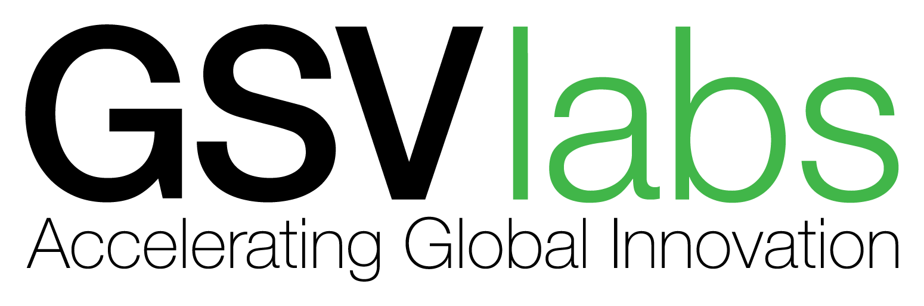
PIONEER ACCELERATOR STARTUP APPLICATION
COMPANY
- Describe your product, Twitter-style (140 characters or less).
- What was your personal motivation for launching your startup? Describe the problem you are solving.
- Please upload your executive summary.
- Does your startup have a technical co-founder?

- Has your startup participated in any other accelerator programs? If yes, please list below.

- Please provide an overview of your startup's cap table.

PRODUCT
- What industry is your startup trying to disrupt or create?
- Have you launched your product?
- If "Yes," when did you launch your product?
If "No," you when do you plan to release your product?
- If you have an online demo, what's the URL?
EXPECTATIONS
- What do you hope to get out of the program?
- If accepted to the accelerator program, will you work full time on this startup with no other external obligations? Please have all co-founders answer.
Business Plan Form (Application Form)
ERA | 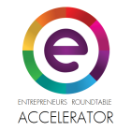
Your First and Last Name:
Your Email:
Your Mobile Phone Number:
Your Kakao ID:
Your LinkedIn profile:
Please enter your LinkedIn profile, degrees and institutions, skills, previous companies and experience (not bio). Also please include your Twitter, HackerNews, Facebook and GitHub handles if applicable. (500 characters max)
Other Founders' LinkedIn profiles:
Please enter other founders' LinkedIn profiles, degrees and institutions, skills, previous companies and experience (not bios). Also please include their Twitter, HackerNews, Facebook and GitHub handles if applicable. (500 characters max)

Company Name:
Company Website:
One sentence pitch of the company:

Pitch video URL:
(Optional) Video of the Founders pitching the company, under 2 minutes please. (Not a product video)
What is your product?:
(500 characters max)
What is the market size/opportunity?:
How big is your market in Korea? And how big is the market in the US? Why is the market attractive? (500 characters max)

What is your business model? :
How do you make money? (500 characters max)
What is the status of your product? :
Please include a link to your product if it's ready to use. What user/customer traction do you have? What is site traffic or user downloads? Active Users? What is the revenue and other relevant metrics? (500 characters max)

Why your team? :
Why will your team win? Please tell us a bit more about previous projects you may have worked on together. Also please tell us about a product or something impressive that each cofounder has achieved. (500 characters max)
What is the status of the company? :
Describe the company structure (Korean corporation, US corporation, etc). How much funding, if any, has your company raised to date? The source of the funding? (500 characters max)
Anything else that you would like to add? :
Include names of advisors, unique team skills, intellectual property, or anything about you, like notable skills or awards. (250 characters max)

NEMIC | 
Application Form:
Your Name: __________________________________________

Your position/title _____________________________________ (N/A if not applicable)

Venture Address: _______________________________________
Business Phone number; _________________________________ (same as your personal number?)

Business Email: ________________________________________

Basic Information about your venture
Name of Venture: ______________________________________

Where do you and will you operate? ________________________ (city and country)

Does your venture fall into one of the following industry clusters?
- Medical Devices: Yes____ No______
- Connected Health Technology: Yes____ No______
- Human Heath: Yes____ No______
Venture established in: _________________________________________
(when did you begin working on your venture idea?)
Number of Team: ______________________________________
Have you incorporated in Korea? _________________________________
Are you planning to incorporate in US after the program? _____________
Venture Stage_______________________________________
Annual operating budget? ____________________________
What does your venture do? (100 characters max)

In which of the following areas could your venture use support?
(Check as many as boxes)
Business Plan Development |  | Market Feasibility Assessment |  | New Product/Services Feasibility Assessment
Leadership Development/Culture |  | Strategic Partnership Development |  | Financial Services (Management, Bookkeeping, etc.)
Budget Development |  | Fundraising Strategies |  | Human Resources
Industry/Peer-organization Best Practices |  | Legal Advising |  | Marketing strategy
Metrics/Impact evaluation |  | Network Building |  | Organizational Development/Strategic Growth
Presentation/Pitch |  | Sales |  | Social Media and Digital marketing
Talent Recruitment |  | Attending investment forum |  | Other: Specify

Are you applying independently or as a team? __________________________
If as a team, list others. _____________________________________________

If accepted, who will attend the accelerator program in US? _______________________
Venture Pitch: What problem are you trying to solve, who do you serve, how are you different, what do you offer (300 characters max)
How much time do you currently devote to your venture hours/week: _______________?
What are your top three goals for the Accelerator, are there particular skills you would like to develop?
- _________________________________________________________
- _________________________________________________________
- _________________________________________________________
In the next year, what are the three biggest challenges your organization will face, how do you plan on overcoming these challenges?
- _________________________________________________________
- _________________________________________________________
- _________________________________________________________

What is your revenue to date from your venture? ______________________
Have you raised startup funds in the past? ____________________________
What is your long term plan for finding financial resources?
Do you have a business plan? If so, please submit the plan along with the application.

What does success look like to you?

Submit your application to applications@nemicenter.com, copy lydia.s@nemicenter.com

Accrete Innovation | 

Registration Form
Please submit your completed form to carol@accreteinnovation.com
Company Information

Company Name
English
Web URL(s)
Year of Registration
Country of Registration
Other Point of Presence
In which countries do you have presence?

Funding Stage
Pre-seed, Seed, Series A, Series B

How are you funded?
Self-funded, Angels, VCs etc.

Are you currently raising funds? What is the amount?

Number of Full-time Employees

About the Company’s Key Solution

Key Solution Focus
(AI, Digihealth, Adtech, IOT, eCommerce, AR/VR, Cybersecurity, Travel, Fintech, etc)

In one sentence, tell us what your company does
Brief Introduction about your company’s business and solution

What problems are you solving? Who are your targeted customers?
Describe the customer/user you are serving and what problem are you solving for this customer/user.

What is the stage of your development?
(ideation, prototype, launched)

If Launched, please describe your current progress or traction. Include customers, user metrics, revenue and any other indicators of progress

Founders’ Information

Name of Founder (1)
First name, Last name

Nationality
Are you a first-time entrepreneur? | Yes / No
Qualification
Diploma, Degree, Masters, PHD etc

LinkedIn URL
Email Address

Contact Number

Brief Profile
Will you be attending the programme? | Yes / No

Name of Founder (2)
First name, Last name

Nationality
Are you a first-time entrepreneur? | Yes / No
Qualification
Diploma, Degree, Masters, PHD etc

LinkedIn URL
Email Address

Contact Number

Brief Profile
Will you be attending the programme? | Yes / No
Others

Why do you want to attend this programme?

What are your main goals?

Would you be able to commit your time in attending up to 4 weeks of acceleration?

Would you be interested in setting up your company in Singapore?

Have you attended other acceleration programmes?

Others useful information

Wayra.U.K. | 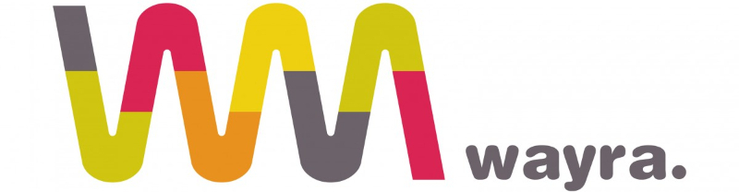

Application Form

Name of company
Twitter pitch (140-character pitch)
URL
What is the problem your start-up is trying to solve?
What solution does your start-up provide?
Market: What market or industry are you targeting with your solution?
Differentiation: What is new about your start-up that cannot be found in your competitors? How competitive is the environment?
Stage: How long have you been working on your idea? What stage of development is your start-up at? How long would it take to launch commercially?
Funding: Do you have short term funding needs? Have you received any kind of funds so far? Taking into account your current funding, monthly expenses and planned investments, how long can the company survive with no other income?
The Team: How big is your team? How many are working full-time on the start-up? Have any of them had experience founding a start-up previously?
What is your country of residence? Will you or any of the other founders need a visa to work in the UK?
Is your start-up registered as a company? Is it registered legally in England and Wales?
Is there anything else you think we should know?
Please attach executive summary

